Strategic Plan Template for an Associate Center,
Cochrane US Network

This document is applicable to Associate Centers only.

This Strategic Plan template is divided into six sections:
- The local environment in which the Associate Center operates
- Current funder priorities / requirements
- How your Associate Center will deliver its Cochrane functions
- Specialisms of the Associate Center
- Challenges and Risks
- Development Plan
Appendix – Overview of functions and tiers – for information

The local environment in which the Associate Center operates
- The use of evidence in your constituency (your organization; the stakeholders you work with; or the geographic state/regional area that your organization covers)
Please describe in brief (approximately 250 words) the state of the use of evidence in decision-making in your constituency and highlight where work needs to be done to improve the use of evidence or other gaps in the evidence system that you think the Cochrane Associate Center needs to fill.
Please enter text here……….

- Priorities
What do you see as the highest priorities for Cochrane in your constituency, and which functional areas are the most important to your Associate Center.
Please enter text here……….

Current Funder / Host Organization priorities / requirements
Many funders or host organizations of Associate Centers add additional requirements to those needed by Cochrane. Please list below what additional work you need to do to fulfil the requirements of your funders / host organizations above and beyond the those required by Cochrane.
Please enter text here……….

How your Associate Center will deliver its Cochrane functions

The newly-established functions for Associate Centers are outlined in the below table. Full details of the functions are available in Implementing Strategy to 2020: Cochrane Centers, Branches & Networks Structure & Function Review.
Associate Centers are expected to respond to these functions in a way that is meaningful in their local context. This template, therefore does not list specific activities, but contains a column requesting details on how the Associate Center intends to fulfil the function. Associate Centers should complete this column with a detailed explanation of activities to be undertaken.
The functions in this form are organised around Cochrane’s four strategic goals:
GOAL 1: PRODUCING EVIDENCE: To produce high-quality, relevant, up-to-date systematic reviews and other synthesized research evidence to inform health decision-making.
GOAL 2: MAKING OUR EVIDENCE ACCESSIBLE: To make Cochrane evidence accessible and useful to everybody, everywhere in the world.
GOAL 3: ADVOCATING FOR EVIDENCE: To make Cochrane the ‘home of evidence’ to inform health decision-making, build greater recognition of our work, and become the leading advocate for evidence-informed health care.
GOAL 4: BUILDING AN EFFECTIVE & SUSTAINABLE ORGANISATION: To be a diverse, inclusive and transparent international organisation that effectively harnesses the enthusiasm and skills of our contributors, is guided by our principles, governed accountably, managed efficiently and makes optimal use of its resources.
The final column asks for targets against which the Associate Center can be measured. You are invited to give short- and long-term targets for each functional area. Please ensure these targets are “SMART” (Specific, Measurable, Achievable, Relevant and Time bound). We advise short term targets to be for one year and long-term targets to be for three years.
Under each Goal there is also a row for “Additional work the Associate Center carries out under Goal X”. This is because the new structure and function review allows all Cochrane Groups much greater freedom to perform other functions outside those required of their Group type. Associate Centers therefore have the opportunity to specify other activities that they do which are worthy of note and should be tracked as part of their performance.
The functional areas in purple are the items in the additional ‘Tier 4’ functions which are not mandatory for Associate Centers.
If you wish to see some examples of activities that might be under taken for each function please see Implementing Strategy to 2020: Cochrane Centers, Branches & Networks Structure & Function Review, pages 16 – 21.

Goal One: Producing Evidence
Functional Area | Tier | How this function will be delivered | Short and long term “SMART” targets.
To engage with external stakeholders locally to inform Cochrane’s review priority setting work. | Two
To support Cochrane authors editors and other contributors in the production of Cochrane Reviews - through mentoring, training and in coordination with relevant Cochrane Review Group Networks) ) a)) and  And/Or  To build capacity amongst targeted stakeholders in the use of systematic reviews and other synthesized evidence.  (Both set of activities to be conducted in collaboration with Cochrane’s Membership, Learning & Support Department). | Two
To undertake searching of local sources, especially non-English sources to contribute to the development of CENTRAL, Cochrane’s register of controlled trials. (Optional) | Four
Additional work the Associate Center carries out under Goal One.

Goal Two: Making our Evidence Accessible
Functional Area | Tier | How this function will be delivered | Short and long term “SMART” targets.
To disseminate Cochrane Reviews locally based on stakeholder networks, the media and other communications channels. | One
To undertake Knowledge Translation (KT) work or work with other Groups in Cochrane to implement KT initiatives locally. (Optional) | Four
To support the work of Cochrane’s consumer network by hosting/supporting a ‘consumer champion’. (Optional) | Four
To support or lead translation initiatives to increase the accessibility of Cochrane Evidence in their native language. (Optional) | Four
Additional work the Associate Center carries out under Goal Two.

Goal Three: Advocating for Evidence
Functional Area | Tier | How this function will be delivered | Short and long term “SMART” targets.
To promote Cochrane and its work. | One
To be Cochrane’s official ‘Representatives’ to the constituency as a member of the Cochrane US Network, in accordance with Cochrane’s Spokesperson Policy. | Two
To build formal or informal local partnerships with key stakeholders to improve knowledge exchange and dissemination of Cochrane evidence. | Two
To host local events, such as symposia, that promote the work of Cochrane, actively develop the contributor base, and build stakeholder links. | Two
Additional work the Associate Center carries out under Goal Three.

Goal Four: Building an Effective and Sustainable Organisation
Functional Area | Tier | How this function will be delivered | Short and long term “SMART” targets.
To support and develop the community of Cochrane members in the US. | One
Additional work the Associate Center carries out under Goal Four.

Specialisms
Most Associate Centers specialise in a certain function or area of work to some degree. Please give details of any particular specialisms of your Associate Center, and where you feel that work in your specialist area means you are delivering less in other functional areas please explain this.
Please enter text here……….

Challenges and Risks
Please provide details of any challenges or risks that might affect your Associate Center’s ability to complete its work over the next three years.
Please enter text here……….

Appendix 1: Functions of Cochrane Geographic Groups
The functions of Cochrane Geographic Groups are all directly built on Strategy to 2020 objectives. The functions are in a tiered hierarchy. Tier One functions must be performed by any Cochrane geographic-oriented Group, however big or small. Tier Two functions must be performed by Associate Centers (formerly Branches) and Centers. Tier Three are functions that Centers must perform as well as those in Tiers One and Two. Tier Four are additional functions that any Cochrane Group would be encouraged to consider, however, Centers must perform at least one Tier Four function. These functions are written as: “It is a core function of Cochrane Centers [to…]”
  - The functions at a glance

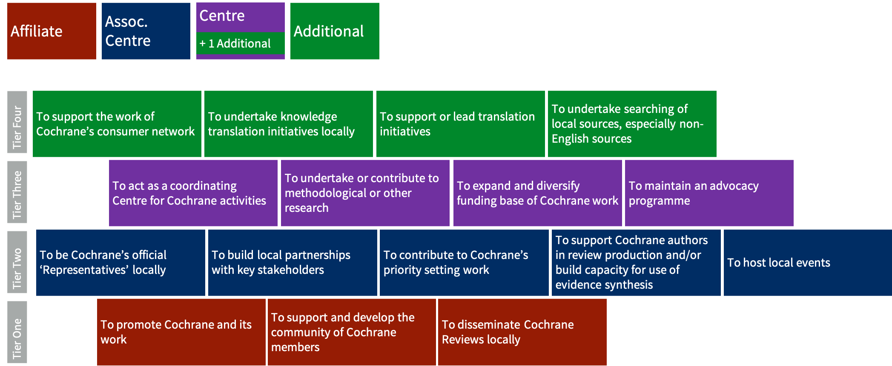

How the tiers map to Groups

